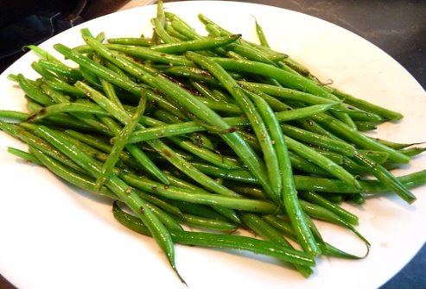

[This Photo](http://chinesegrandma.com/2010/08/green-beans-feta-balsamic-vinegar/) by Unknown Author is licensed under [CC BY](https://creativecommons.org/licenses/by/3.0/)

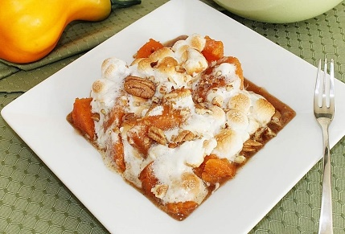

[This Photo](http://www.receitasesaboresdomundo.com/2011/11/batatas-doces-com-marshmallows-sweet.html) by Unknown Author is licensed under [CC BY-SA-NC](https://creativecommons.org/licenses/by-nc-sa/3.0/)

GREEN BEANS SWEET POTATOS

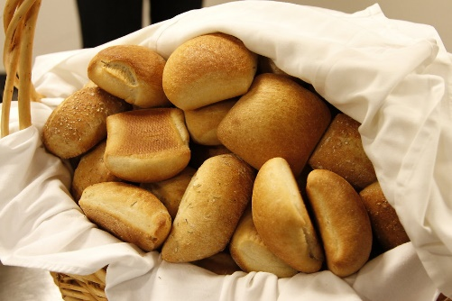

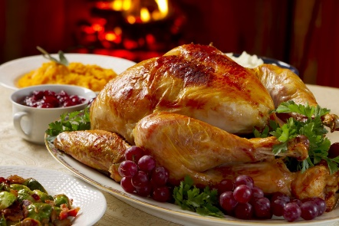

[This Photo](https://courses.lumenlearning.com/wmopen-introbusiness/chapter/why-it-matters-12/) by Unknown Author is licensed under [CC BY](https://creativecommons.org/licenses/by/3.0/)

ROLLS TURKEY

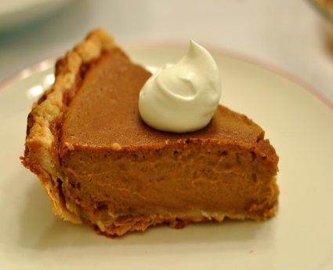

[This Photo](http://www.flickr.com/photos/kimberlykv/5216067323/) by Unknown Author is licensed under [CC BY](https://creativecommons.org/licenses/by/3.0/)

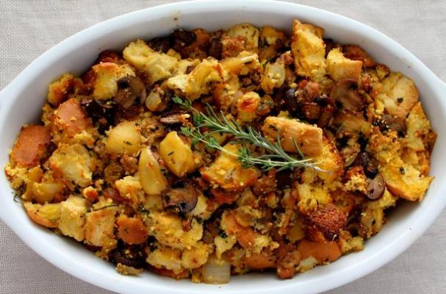

[This Photo](http://www.foodista.com/blog/2013/11/22/10-spectacular-turkey-stuffing-recipes) by Unknown Author is licensed under [CC BY](https://creativecommons.org/licenses/by/3.0/)

STUFFING PIE